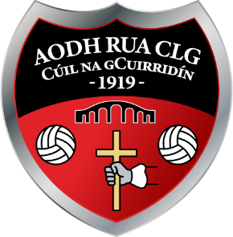

Outgoing Officers

Chairman - Cathal Doherty Vice Chairman – Bernard Devine

Secretary - Kathy Kelly Assistant Secretary – Carol Gallagher

Treasurer - Marie Mc Colgan Assistant Treasurer - Alice Doherty

Registrar - Jennifer Mc Menamin PRO – Sean Sweeney

Scór – Maranna Sweeney Coaching Officers – Pj Gallagher/Maura Mc Crudden

Development Officer - Martin Doherty Child Protection Officer – Eithne Browne

Health & Wellbeing/Healthy Club Officer(s) – Terri Kelly & Liam Doherty

Player Reps – Men: Gerard Melaugh & Ryan Kelly

Ladies: Olivia Dullaghan & Brianna Mc Connell

GAA County Board Delegates - Tommy Mc Glinchey & Andy Doherty

Northern Board Delegates - Cathal Doherty & Martin Doherty

LGFA County Board Delegates – Cathal Doherty & Eimear Gallagher

Nomination
of
Officers.

Chairman:

Vice Chairman:

Secretary:

Assistant Secretary:

Treasurer:

Assistant Treasurer:

P.R.O.:

Registrar:

Culture Officer(s) (Scor): _______

Child Protection Officer: *******************************************

Health & Wellbeing Officer: ___________________________________________

Development Officer: ______________________________________________

Coaching Officer(s): __________________________________________

Players Representative: (M) _____________________________________________

(L) _____________________________________________

County Board Delegate 1:

County Board Delegate 2:

Northern Board Delegate: ____________

SIGNED: __________________________________

MOTIONS

Name: ____________________________
Date: ____________________________

